**Rational Numbers**

Any number that can be written as a ratio is a rational number. Any ratio can be written as a fraction.

This means

**Any Fraction = A Rational Number**

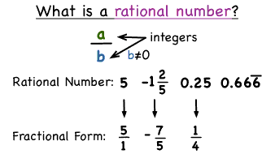

**Ratio**nal Numbers

Any square root of a perfect square is rational. The square root of any non-perfect square is irrational

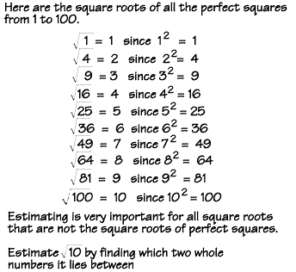

**Irratio**nal Numbers are the opposite of rational

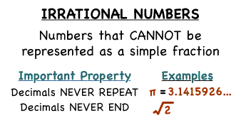

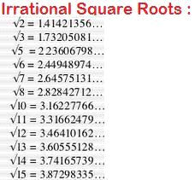

**Combining Like Terms**

**Combining Like Terms**

(Add and subtract the things we can)

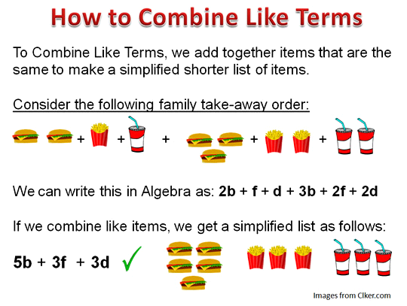They have to have the **same base** and the **same exponent** to be able to be combined

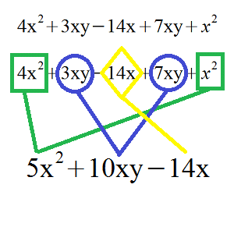

**The Distributive Property**

Multiplying Binomials

Using Double Distribution

****Stay Organized****

(DRAW THE ARROWS)

(FOIL)

First, Outside, Inside, Last

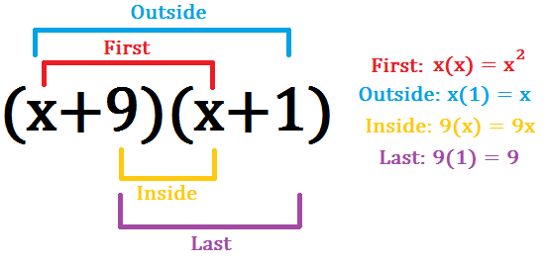

First: Distribute to the other siiide! 

That means you have to multiplyyyy ….

Draw arrows, to keep you, ooorganized….

Distribute to the other siiiiiiiiide.

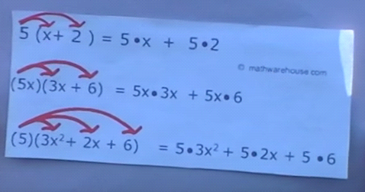

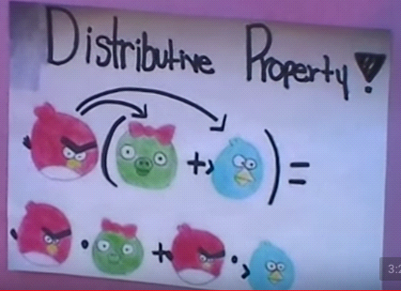

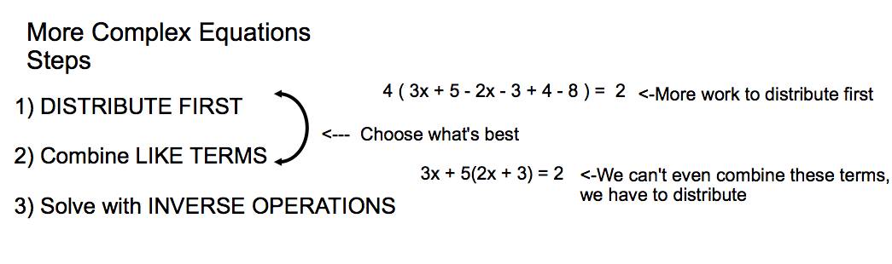

**Solving Inequalities**

**When To Flip The Sign**

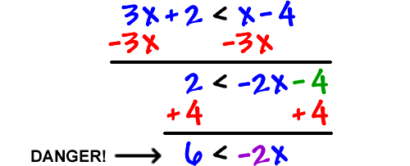

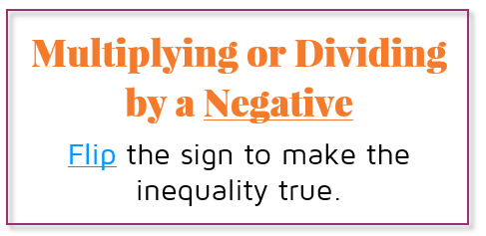

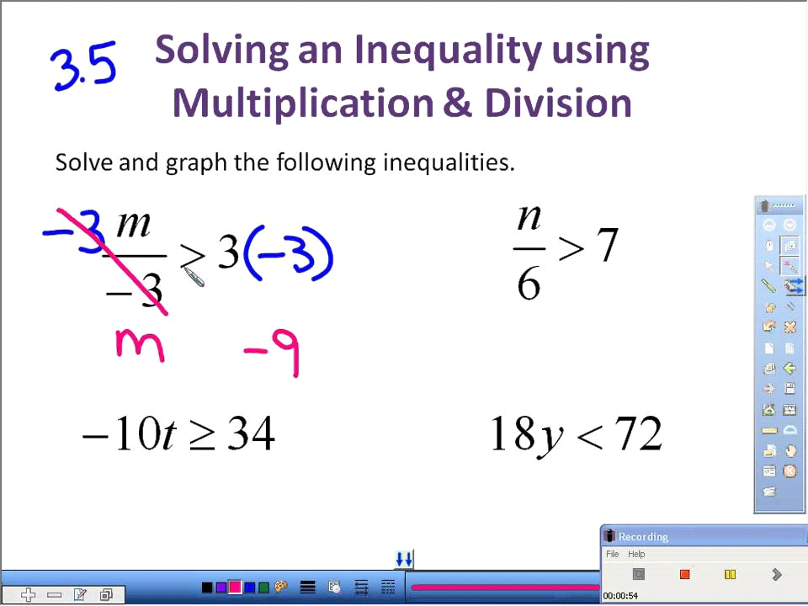

**Graphing Inequalities**

**When is it “AND,” when is it “OR?”**

**This is the same picture!!! Yes, because it tells us so much**

I’ve heard you ask more than once so we really need to investigate this idea and understand it.

**Look closely at the last example**

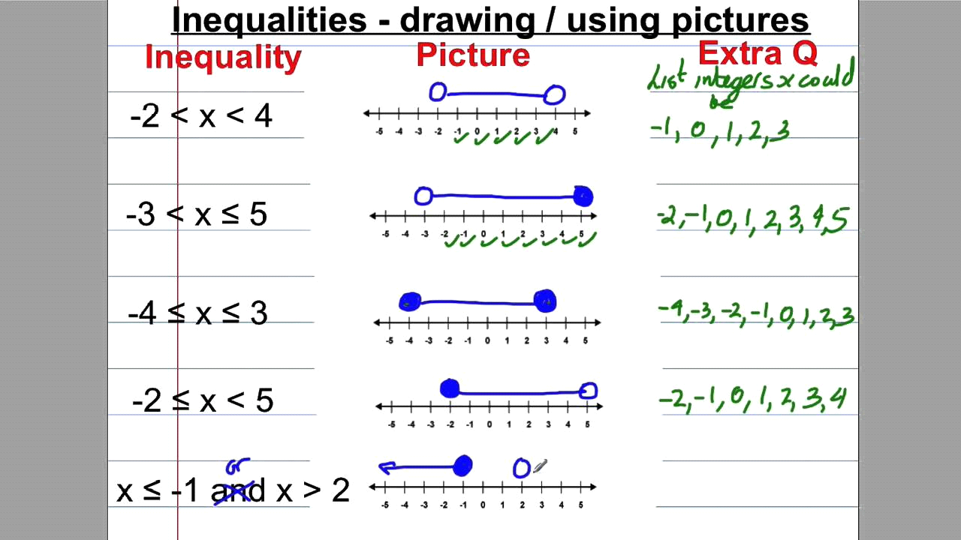

* **Last E.g., Above:**
* (Notice: The scribble replacing And with OR). This person graphed the first part, x < -1.
* The second part reads, “X is greater than 2.” So we think, the variable is bigger, go to the number and draw a **not** filled in circle (because of the sign <) and point… Wait, so X is greater, so the variable is bigger, so…..

This person stopped graphing to fix the statement! The arrows would point away from each other, it had to be and OR

**OR=**Arrows **pointing away** from each other.

**AND=**When the circles **connect to form a line** segment**.**

**Graphing Inequalities Continued….**

**Finding Solution Sets** for Compound Inequalities using your Graph (worth the read)

* **READ** the inequality, remember the variable in the middle is read in both statements. **AFTER** you read the statement, think to yourself, IS THE **VARIABLE** BIGGER OR SMALLER**?**”
* First E.g., Below: -2 is less than x,…..so x is “bigger” (then) find -2 on the number line and draw a circle, **not** filled in **(<),** and point the arrow in the direction of “bigger” numbers.
* First E.g., Below: The second part, with the shared variable reads, “x is less than 4,”…..so X is “smaller” (then) find 4 on the number line and draw a circle, **not** filled in **(<),** and point the arrow in the direction of “smaller” numbers.



**Order of Operations** in general

I know we’ve all heard PEMDAS. The “P” for Parenthesis should really be a “G” for Grouping in High School and beyond when we have things like square roots. Try to think GEMS.

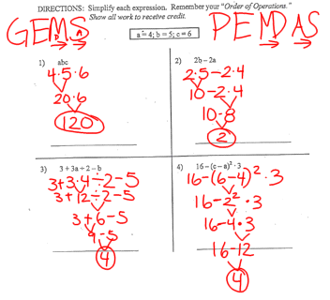

**Math Properties**  in general 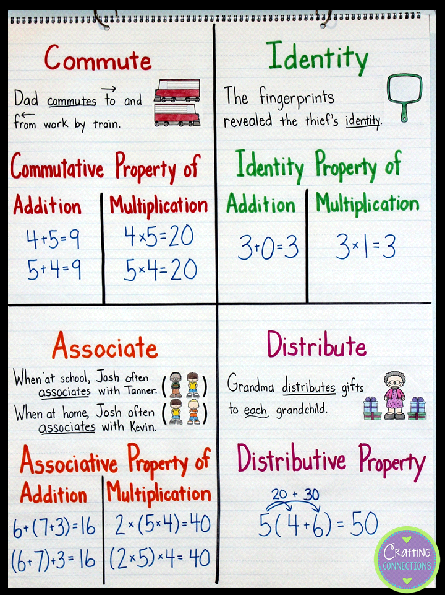 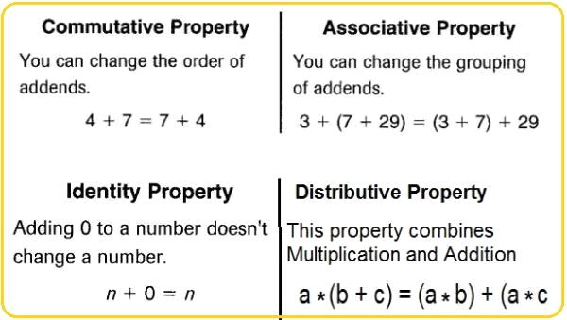

**Laws of Exponents** in general

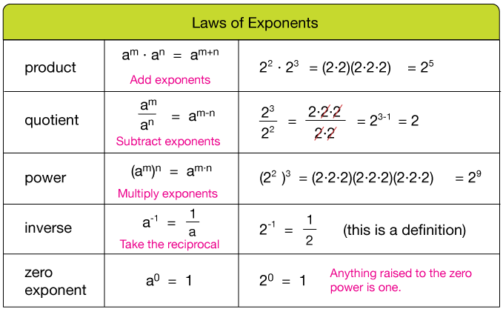**Some Examples**

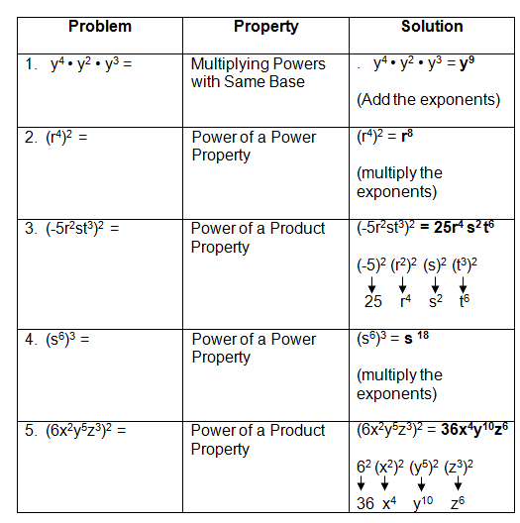

**Law of Exponents** zero exponents

**ANYTHING TO THE**

**POWER OF ZERO EQUALS 1**

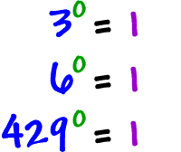

**EVEN FRACTIONS!!!!!** The denominator can never be zero, in general, for ANY fraction, ever, ever, ever, that is called **undefined**. We literally can’t define it!!! So that scenario doesn’t exist to us as mathematicians.

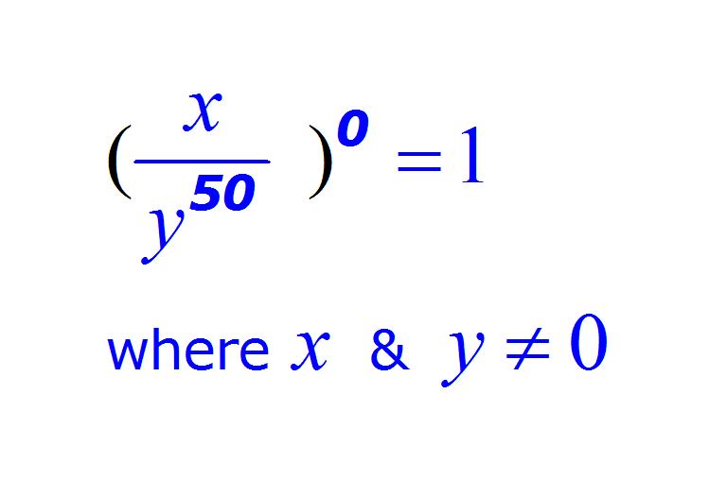

**Negative Exponents** in general

**Flip it exponent becomes positive**

(Math Language: Find the positive reciprocal)

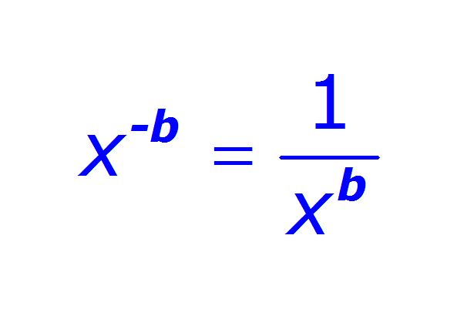

Negative exponents example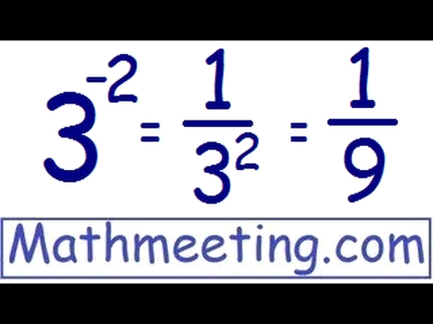

**Translating Expressions** in general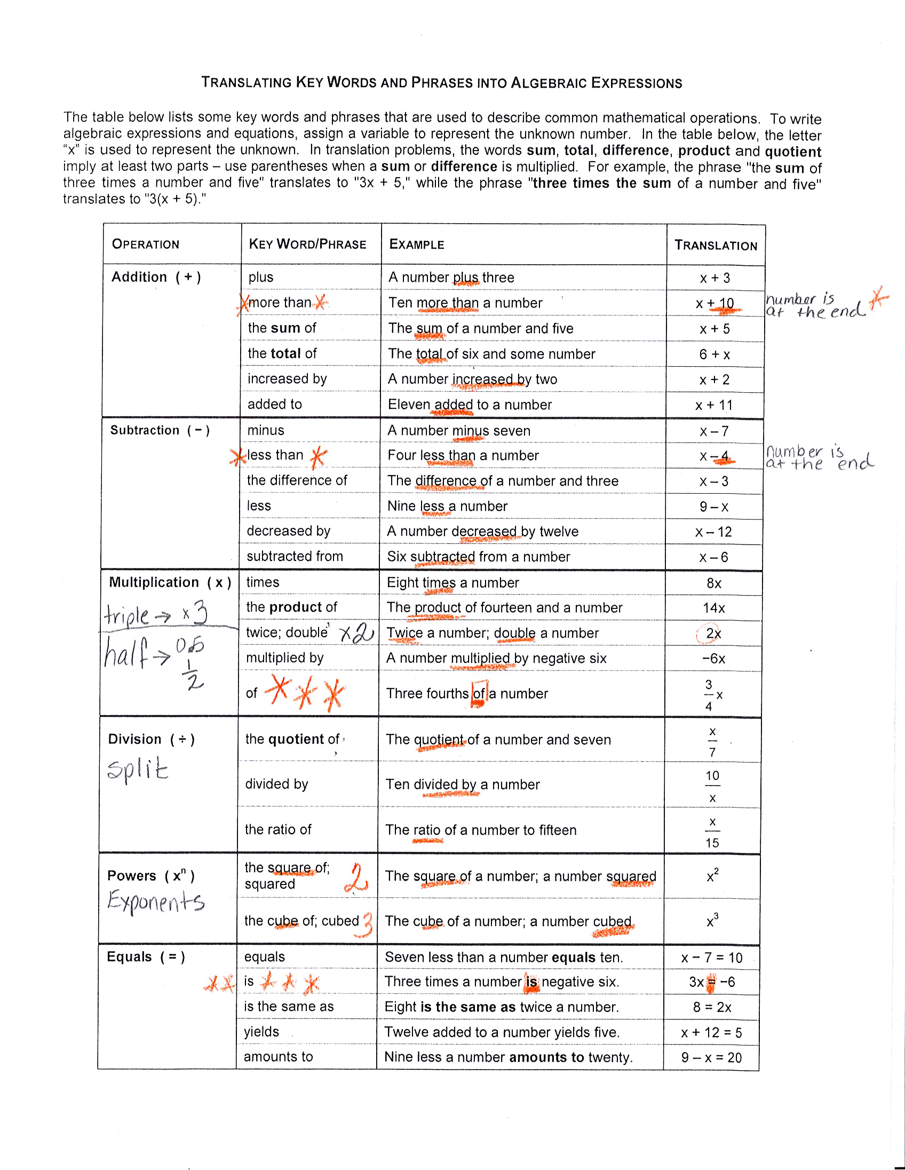 **Translating Expressions** examples 